SARS-CoV-2 Update
October 19, 2020

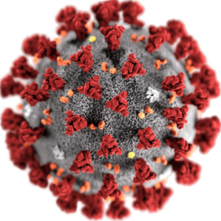

Table of Contents

Background and Scope 3
Risk Assessment 3
Global Case Statistics 10/19/2020 4
U.S. Case Statistics 5
What is a coronavirus? 6
Practical Guidance 6
Symptoms 6
COVID-19 and Pregnancy- Research Updates 7
Transmission 8
COVID-19 risk and School Attendance 9
Symptoms and Transmission FAQs 9
Can SARS-CoV-2 be transmitted on packages? 9
Can ultraviolet light kill SARS-CoV-2? 10
Testing, Prevention and Treatment 10
Testing update 10
Testing Overview 10
Testing for active COVID-19 infection (molecular testing) 11
Testing for previous COVID-19 exposure (serology testing) 11
Can I become re-infected with SARS-CoV-2 once I have had it already? 12
Prevention and Treatment 12
Drugs 12
Should I wear a face mask? 14
Hygiene Practices to Reduce SARS-CoV-2 Transmission 15
Will a flu shot protect me against COVID-19? 16
Managing Illness and Return to Work 16
If I have COVID-19, when can I discontinue isolation (return to work)? 16
1. Symptom-based Strategy 17
2. Test-based Strategy 17
What should I do if I have had close contact with someone with presumed or laboratory-confirmed COVID-19? 18
What if I have already had a positive COVID-19 test? 19
Close Contact Scenarios (including contacts in the same household) 19
What should I do if I have been in contact with a contact of a laboratory-confirmed case of COVID-19 (“contacts of contacts”)? 21
Travel Considerations 22
International Travel 22
Domestic Travel 24
What should I do if I have recently returned from traveling? 24

Background and Scope
SARS-CoV-2 is a coronavirus that caused a pneumonia outbreak in Wuhan, China in December 2019. This outbreak has evolved into a global pandemic.
  - Risk Assessment
The SARS-CoV-2 public health threat continues to be high in the U.S. and worldwide. COVID-19 case numbers and COVID-19 related deaths continue to rise. There are> 33 million cases globally, and over 1 million COVID-19 related deaths. Cases are rising in the United States, Europe the middle east. Annual deaths in the United States are 20% higher than expected so far for 2020, and this number is slated to increase. A recent CDC Morbidity and Mortality Weekly Report (MMWR) found “hotspot” rates of COVID-19 infection to first demonstrate increases in young people (< 24 years old), followed by those in individuals >24 years old weeks after. A 10/2/2020 CDC MMWR report found COVID-19 incidence in children aged 12-17 to double that of children aged 5-11 years old.
WHO has issued statements countering the natural development of herd immunity due to ethical concerns. It was reinforced that herd immunity is typically achieved by vaccinating a proportion of the community. Historically, there has never been a public health recommendation to achieve herd immunity by any means other than by vaccination.
Three Phase 3 trials have been placed on hold: two vaccine trials, and one monoclonal antibody treatment trial. These include the following:
- Johnson and Johnson/Janssen single dose COVID-19 vaccine trial involving 60K participants due to unexplained illness in a participant.
- AstraZeneca vaccine trial placed on hold in September due to neurological complication in a study participant. This was removed a week later, but the U.S. faction continues to be paused pending FDA investigation
- Eli-Lilly monoclonal antibody treatment trial
The Novavax COVID-19 vaccine (NVX-CoV2373) has entered its Phase 3 efficacy trial, involving 10K participants across the U.K. Study goals of this phase are two-fold: to assess COVID-19 incidence post-vaccine, and determine the timeline to moderate or severe COVID-19 in new cases.
Treatment updates include the following:
- The NIH has expanded convalescent plasma trials amongst individuals with COVID-19.
- A preventative nasal spray called INNA-051 has been found to reduce COVID-19 viral replication in animal study.

Testing updates include:
- FDA Emergency Use Authorization of IgM antibody fingerprick test (AdviseDX SARS-CoV-2 IgM). IgM antibodies are the first to increase in the setting of infection.
In Helsinki, Finland, a COVID-19 dog sniffing program has been deployed in airports to identify COVID-19 upstream of symptom onset. Humans provide samples by wiping their skin with a wipe. COVID-19 detection dogs have also been employed in Germany, albeit trained using respiratory secretions from hospitalized patients.

Global Case Statistics 10/19/2020
Source: Johns Hopkins University

U.S. Case Statistics
Source: Johns Hopkins University

Terminology
SARS-CoV-2- the name of the coronavirus
COVID-19 (“Coronavirus disease 2019”)- the name of the disease SARS-CoV-2 causes
  - What is a coronavirus?
Coronaviruses are a family of viruses. Some strains of coronavirus cause mild illness, such as the four responsible for the common cold. Others can lead to severe and even fatal disease. These include the Middle East Respiratory Syndrome Coronavirus (MERS-CoV), which continues to circulate in some parts of the world, and Severe Acute Respiratory Syndrome (SARS), which is no longer in circulation. SARS-CoV-2 is a betacoronavirus, like MERS-CoV and SARS, which originate in bats. The WHO has confirmed that the source of the virus is zoonotic, and not “man-made.” This conclusion has been endorsed by U.S. intelligence experts.

Practical Guidance
  - Symptoms
Symptoms of SARS-CoV-2 include the following:
- Temperature >100.4 degrees Fahrenheit
- Cough that is new or worsened from baseline
- Shortness of breath
- New-onset muscle pain
- New-onset headache
- Chills
- Repeated shaking with chills
- Sore throat
- New-onset loss of taste or smell
- Nausea/vomiting
- Diarrhea

Most cases of COVID-19 are mild. These individuals do not require hospitalization and recover completely (>80%). Severe COVID-19 is more likely to develop in individuals with underlying medical conditions, such as heart disease, diabetes and lung disease. It is thought that ~16% of cases may be severe.
Some individuals have reported symptoms of COVID-19 to linger for up to 2 months. A study in the New England Journal of Medicine has found the 3p21.31 gene cluster to be associated with more severe COVID-19 presentation, and posited involvement of the ABO blood type system. Compared to other subgroups, risk was increased for individuals in the “A” blood type, and there was a protective effect for the “O” subtype.
COVID-19 primarily affects the respiratory tract (lungs), but has also been shown to affect the gastrointestinal system, heart, blood vessels (clotting), kidneys and liver. There are reports of younger middle-aged patients (30 to 40 years old) suffering severe strokes, and blood clots traveling to the lungs (pulmonary emboli). Neurologic and psychiatric complications have also been reported.
COVID-19 has been associated with a unique presentation in pediatric patients referred to as Multi-System Inflammatory Syndrome in Children (MIS-C). This syndrome is characterized by abdominal pain, fever, rash, and vascular complications appearing several weeks after either symptomatic or asymptomatic COVID-19 infection. Several pediatric deaths have been reported from cardiac complications of this newly described syndrome. A study in the New England Journal of Medicine found most of the children in the study to have been previously healthy.
CDC has expanded the definition of individuals at high risk of severe disease to younger Americans with underlying illness or health conditions, as well as pregnant women. Conditions with strong evidence to increase COVID-19 disease severity include: cardiovascular disease, chronic kidney disease, chronic obstructive pulmonary disease (COPD), obesity, any condition that suppresses the immune system, sickle cell disease, a history of an organ transplant, and Type 2 diabetes. Other medical conditions that may increase the risk of severe illness include chronic lung diseases, (e.g. moderate to severe asthma and cystic fibrosis), high blood pressure, a weakened immune system, neurologic conditions, (e.g. dementia or history of stroke), liver disease, and pregnancy.

COVID-19 and Pregnancy- Research Updates
A study in Nature demonstrated evidence of vertical transmission of COVID-19 to babies in utero. A cohort of 101 neonates born to mothers with perinatal COVID-19, however, found only 2 participants to test positive for SARS-CoV-2 at birth, in whom the disease did not manifest clinically (JAMA Pediatrics). Most of these infants breastfed and roomed with their mothers. Fifty-five participants followed up after birth did not develop COVID-19 infection.
A JAMA study of nearly 3,000 mothers presenting in labor found mothers with COVID-19 to be more likely to have preeclampsia. There was no statistically significant difference in other outcomes measured, such as bleeding after delivery, preterm birth, mode of delivery, postpartum hemorrhage, and birthweight for gestational age. The PRIORITY study in San Francisco, California of 300 mothers and their babies followed up to 8 weeks after birth found no association between maternal COVID-19 status and birthweight, difficulty breathing or respiratory infection.
  - Transmission
Transmission of SARS-CoV-2 is primarily person-to-person. It is spread from an infected person to close contacts via large respiratory droplets and small particles, such as those in aerosols, expelled with coughing, sneezing, talking and breathing. There is some evidence that ocular fluid (fluid in the eyes) may also be infectious. Research has found normal human speech to emit droplets that linger in the air for up to 14 minutes. Droplets have even been detected to survive in the air for up to 3 hours.
SARS-CoV-2 transmission is occurring via community spread, or between persons for whom the source of exposure is unknown. Risk is thought to be higher in cramped, indoor areas with poor circulation than outdoors. A study conducted in Japan found COVID-19 transmission to be 18.7% higher in a closed (indoor) than open-air environment.
Individuals are most contagious from 48 hours before symptoms occur, and remain contagious while infected. Individuals can spread COVID-19 even if they are not exhibiting symptoms. This may be due to individuals inaccurately gauging the presence of symptoms, true “asymptomatic spread,” where individuals appear to be healthy, or “pre-symptomatic” spread during the 48 hours prior to symptom onset. The majority of transmission results from individuals who are symptomatic or pre-symptomatic.
The virus has been detected in animals, but there is insufficient evidence whether animals serve as an intermediate reservoir for infection, and/or have the ability to infect humans. Farmed minks in Denmark and the U.S., were recently found to harbor SARS- COV-2. The U.S. Department of Agriculture does not currently recommend routine testing of animals. The USDA list of SARS-CoV-2 infected animals can be found here. Per the CDC, the risk of animals spreading COVID-19 to people is considered to be low, although people are thought to have the capability to spread the virus to animals.
Transmission via SARS-CoV-2 particles on contaminated surfaces is not thought to be the main mode of transmission. Regular decontamination of surfaces is nonetheless recommended as a mainstay of SARS-CoV-2 prevention. SARS-CoV-2 has been found to live on hard surfaces, such as stainless steel or plastic, for up to 2-3 days. A recent study in the Journal of Korean Medical Science demonstrated regular surface decontamination to eliminate the presence of airborne and surface of the virus.
SARS-CoV-2 has not been shown to live on clothing, but CDC has recommended against shaking laundry and clothing of individuals infected with the virus. It is unclear as to whether SARS-CoV-2 spreads via the fecal oral route. The virus has been found to be present in stool, but is thought to be inactivated in the lumen of the colon. Per CDC there is no evidence to suggest handling or consuming food is associated with COVID-19.

COVID-19 risk and School Attendance
Please consult local and institutional guidance for updates regarding school attendance.
CDC Guidance for Schools and Childcare Programs can be found at the following url: https://www.cdc.gov/coronavirus/2019-ncov/community/schools-childcare/index.html

  - Symptoms and Transmission FAQs
How contagious is SARS-COV-2?
“R-naught,” or “Ro” is a term that describes how easily a virus is transmitted from one source to another. The higher the Ro value, the more contagious the virus.
SARS-CoV-2 is estimated to have a “Ro” value of ~2-4. This means that a person with SARS-CoV-2 without implementing any mitigation strategies, will infect ~2-4 susceptible individuals with whom they come into contact. This compares to other viruses as follows:
Virus | R-naught (Ro)
Measles | 11 - 18
Zika | 3 - 6.6
SARS-CoV-2 | 2 - 4
Ebola | 2
The value of “R-naught,” or “Ro” is being used in some countries as a fluctuating metric of infection risk. In this case, lower values correspond to lower risk of infection.

Can SARS-CoV-2 be transmitted on packages?
Per the WHO, the likelihood is low that an infected individual can contaminate commercial goods. The risk is also low that SARS-CoV-2 can be transmitted from a package that has moved, travelled, and been exposed to different conditions and temperature. A recent study showed SARS-CoV-2 to remain on cardboard for up to 24 hours, but similar to hard surfaces (stainless steel and plastic), it is unclear how much of the virus remains viable. It has been deemed reasonable to utilize a disinfectant wipe on cardboard surfaces as a precaution.

Can ultraviolet light kill SARS-CoV-2?
A study in the American Journal of Infection Control found 222 nm Ultraviolet C light (UVC or Far-UVC) to be effective at killing SARS-COV-2 This is safer than the 254 nm wavelength used in many commercially available systems, which can cause skin and eye problems.

Testing, Prevention and Treatment

Testing update
CDC now recommends that all close contacts of individuals with COVID-19 obtain a molecular COVID-19 test. This recommendation was issued in light of increasing evidence for asymptomatic and pre-symptomatic transmission.
A 14 day close contact quarantine is required even if the molecular COVID-19 test results negative. Quarantine starts on the date of last close contact. Individuals cannot “test out” of close contact quarantine.

Testing Overview
The CDC, commercial labs (e.g. LabCorp, Quest), and some healthcare systems have developed laboratory test kits to test patient specimens for SARS-CoV-2. To date, there are 80 tests that have received “Emergency Use Authorization” (EUA) from the Food and Drug Administration (FDA). False negatives and false positives do occur with both types of tests, and due to limited availability, many have restrictions on who can have them performed. Both possibilities are concerning due the potential for increased transmission. An individual with a “false negative” result may continue to unknowingly spread the virus, particularly if asymptomatic, and a “false positive” result can lead to false reassurance that an individual is developing immunity to COVID-19, even though susceptibility to the virus is actually unchanged.
There are a number of other COVID-19 tests in development and moving through EUA protocols. Some tests are available commercially that have not received EUA by the FDA. These have not been vetted through FDA protocols, and are likely to produce unreliable results. The list of tests that have received EUA can be found at the following URL (on the FDA website). This information is updated, and can be used for reference to “cross-check” tests that you encounter commercially: https://www.fda.gov/medical-devices/emergency-situations-medical-devices/emergency-use-authorizations#covid19ivd.
Two types of COVID-19 tests have received emergency use authorization: molecular tests and serology (blood) tests.
  - Testing for active COVID-19 infection (molecular testing)
The COVID-19 molecular assay tests a nasal or throat swab or saliva for pieces of viral genome (RNA). This indicates active viral replication, or acute COVID-19 infection. Abbott Labs offers a rapid molecular point-of-care COVID-19 test called ID-now. This test uses existing PCR technology, and also results in 15 minutes. A recent study found false negative rates for this test to be as high as 48%, depending on sample type. There is new technology close to FDA approval that uses “CRISPR” capabilities to recognize COVID-19 DNA, and is almost 100% accurate. This will be available only as an in-lab test.
On May 8th the FDA gave Emergency Use Authorization to novel testing technology that detects the COVID-19 antigen. This test is called the Sofia 2 SARS Antigen test, and is produced by the Quidel Corporation. It results in as little as 15 minutes, and can be performed in a lab or at the point-of-care by trained personnel under a CLIA certificate of waiver. “CLIA” stands for Clinical Laboratory Improvement Amendments (promulgated in 1988). CLIA waived tests can be run in non-laboratory patient care settings, such as an on-site clinic.
LabCorp and Quest Labs are currently offering COVID-19 tests that can be performed by individuals at home. At home tests can be obtained by the individual or physician order. Individuals requesting tests must fill out an on-line questionnaire, and if “qualified” receive a test kit, perform a nasal swab, and send the kit back to the lab. A COVID-19 saliva test developed by a lab at Rutgers University has also received EUA to be performed at home. Previously it was approved for lab use only. This test requires a physician order, and can be run only at the Rutgers University Lab.
Many healthcare facilities have created “drive-by” COVID-19 molecular testing stations located outside of the healthcare facility. These are designed to reduce transmission of the virus during the testing process. Criteria for COVID-19 testing may differ by state. Check your state public health department website for local guidance.
  - Testing for previous COVID-19 exposure (serology testing)
The COVID-19 serology assay tests human blood for COVID-19 antibodies, which signify evidence of previous COVID-19 exposure, and possible current immunity. Antibody testing is always performed utilizing blood, and there are no point-of-care approved technologies at this time. These specimens would all have to be run in a CLIA certified lab.
Immunity has not clearly been established by any scientific studies. It is unclear whether the presence and number of antibodies indicates whether immunity is present, the strength of the immune response, and how long immunity lasts. Immunity would allow individuals to resume normal daily activities. A recent study demonstrated a decline in SARS-CoV-2 antibodies after only 2-3 months.

Can I become re-infected with SARS-CoV-2 once I have had it already?
Cases of re-infection have been reported within 2-3 months of initial infection. Some of these individuals have presented with milder disease, while others have developed more severe symptoms. One case was fatal. Testing revealed some of these individuals to have contracted a different strain of SARS-CoV-2.
  - Prevention and Treatment
To date, there is no specific antiviral therapy recommended to prevent or treat SARS-CoV-2. The FDA has neither authorized nor approved any COVID-19 “treatment” for commercial use, and has issued a number of warning letters to products claiming to have preventive, treatment, or curative capabilities. Social media sites including Facebook and Twitter have enacted COVID-19 misinformation policies to combat the spread of inaccurate information.
Antibiotics are only effective against diseases caused by bacteria. They are not active against viruses, like SARS-CoV-2, but are sometimes utilized to treat secondary bacterial infections.
Patients with COVID-19 should receive supportive care to relieve symptoms and prevent complications during recovery. This can range from ibuprofen or acetaminophen for fever, to mechanical ventilation for severe respiratory difficulty (severe cases only). Ibuprofen and other non-steroidal anti-inflammatory drugs have not been contraindicated in treating fever and other COVID-19 symptoms (e.g. muscle aches)
Vaccine development is underway.
The New York Times Vaccine tracker can be found at the following url: https://www.nytimes.com/interactive/2020/science/coronavirus-vaccine-tracker.html

Drugs and Treatment
The New York Times Coronavirus Drug and Treatment Tracker can be found at the following url: https://www.nytimes.com/interactive/2020/science/coronavirus-drugs-treatments.html?auth=login-google
The anti-viral drug “Remdesivir” against COVID-19 has demonstrated benefit in treating COVID-19. Gilead, a pharmaceutical company that produces Remdesivir, is ramping up production, and is projected to produce ‘several million’ courses of this treatment by the end of 2020. It has been granted Emergency Use Authorization by the FDA. Emerging data has revealed infusion reactions, liver and kidney damage to be notable side effects. The NIH has recently launched a clinical trial using Remdesivir in combination with Baricitinib, an anti-inflammatory drug used for moderate to severe rheumatoid arthritis. Infusion of “convalescent plasma” containing SARS-CoV-2 antibodies from individuals who have recovered from COVID-19 has also shown some benefit, particularly in treating critically ill patients. Its utility in preventing COVID-19 in individuals unexposed to SARS-CoV-2 is under investigation.
The anti-malarial drug “Hydroxychloroquine” has not been promising in treating or preventing COVID-19. The FDA has removed the Emergency Use Authorization for this medication to be used for COVID-19. One study found hospitalized patients taking hydroxychloroquine to be twice as likely to die, as well as more likely to develop ventricular arrhythmia. This risk was compounded with concurrent use of a macrolide antibiotic (e.g. azithromycin). Results from a NIH-funded clinical trial at the University of Minnesota did not find this therapy to be effective in preventing COVID-19 compared to a placebo. =
The following therapies have also failed to prove clinical therapeutic benefit for COVID-19: zinc, elderberry, silver, turmeric, famotidine Vitamin C, and Vitamin D.
Intravenous immunoglobulin (IVIG) and steroids has shown some benefit in treating children and youth with Multi-System Inflammatory Syndrome in Children (MIS-C).
The anti-arthritis drug “Kezvara” has shown some benefit in treating critically ill patients, and trials of nicotine therapy have begun in France. Trials of Remestemcel-L, a stem cell therapy, have shown treatment to be beneficial in COVID-19 patients with moderate to severe acute respiratory distress syndrome (ARDS). The postulated mechanism involves countering the immune dysregulation, or “cytokine storm” deemed responsible for the abrupt, late-stage acute respiratory decompensation seen in these patients.
  - Should I wear a face mask?
Facemasks and social distancing continue to be one of the most important means of SARS-CoV-2 prevention. The CDC has recommended that individuals in the community wear cloth face masks in public places in addition to social distancing measures.
Cloth masks do not replace social distancing, but do provide some added protection against COVID-19 transmission. This is particularly true in areas where it is difficult to maintain 6 feet of distance. Some states have mandated face coverings in public, and instituted fines to those who do not comply.
More information and tips for creating your own cloth face mask can be found at the following link: https://www.cdc.gov/coronavirus/2019-ncov/prevent-getting-sick/diy-cloth-face-coverings.html
Fitted respirators, which include ‘P2’ or ‘N-95’ masks, are effective in preventing infection, but require training and special fitting to be used properly. They are not intended for use in a general setting. Research has revealed many of the KN95 facemasks imported from China do not meet protection standards in place for N-95 masks. They should not be considered equivalent in terms of protection.
Preliminary U.S.-based research regarding cloth face masks has revealed non-porous materials to be superior to porous materials in filtering particles. Filtering is thought to occur via both physical blocking and “electrostatic filtering.” A different study found a polyester bandana to filter 40% of suspended particles, and four-ply-microfiber cloth to filter >75% of particles. An N-95 fitted respirator mask filters 95% of particles by comparison. It has been recommended that cloth facemasks are washed daily in hot water.
There shortage of respirators and other personal protective equipment (PPE) for healthcare workers nationwide. CDC recommends that surgical masks and respirators (e.g. P2 or N-95 masks) are reserved for healthcare workers at risk for COVID-19 infection.
There has been an increase in N-95 and other respirator masks available on the market, some of which have not received FDA approval or emergency use authorization (EUA). The list of personal protective equipment that has received emergency use authorization can be found on the FDA website, at the following url: https://www.fda.gov/medical-devices/emergency-situations-medical-devices/emergency-use-authorizations#covid19ivd
  - Hygiene Practices to Reduce SARS-CoV-2 Transmission
COVID-19 transmission risk can also be reduced by following general precautions for hand hygiene, respiratory hygiene and good food safety practice:
- Clean hands frequently, using an alcohol-based hand rub or soap and water. Carry hand sanitizer for use on-the-go.
- Avoid touching your face, mouth or eyes.
- If you cough or sneeze, cover your mouth and nose with a flexed elbow or tissue. Throw the tissue away immediately and wash your hands.
- Avoid close contact with anyone obviously sick (e.g. with runny nose, congestion, muscle aches, fever or cough).
- If you develop upper respiratory symptoms, fever, cough and/or difficulty breathing, seek medical care right away. Share previous travel history with your health care provider.
- Do not travel if you are sick. Some locations have begun screening travelers, which may cause you to undergo quarantine and testing.
- Thoroughly cook all food, including eggs.
- Raw meat, milk or animal organs should be handled with care to prevent cross-contamination with uncooked foods, as per good food safety practices
- When visiting live markets, avoid direct unprotected contact with live animals, including surfaces in contact with animals

Will a flu shot protect me against COVID-19?
Annual influenza vaccination will not protect against SARS-CoV-2. However, individuals without contraindications to receiving the annual influenza vaccination should still obtain their flu shot. This has been endorsed by both CDC and the American Medical Association (AMA).
It is possible to be sick with the flu and COVID-19 simultaneously, and according to a recent study from Public Health England (PHE), this may cause co-infected individuals to be “more than twice as likely to die as someone with the new coronavirus alone.” In fact, those with co-infection are ~6 times more likely to die than individuals with SARS-CoV-2 alone, and those with SARS-CoV-2 are 2.61 times more likely to die than those without the virus.

Managing Illness and Return to Work
  - If I have COVID-19, when can I discontinue isolation (return to work)?
COVID-19 cases need to self-isolate (quarantine) for minimum of 10 days.
You are a COVID-19 case if you have:

- A positive COVID-19 test result (molecular/PCR test for active COVID-19)
- Any symptom of COVID-19, including:
  - Temperature >100.4 degrees Fahrenheit
  - Cough that is new or worsened from baseline
  - Shortness of breath
  - New-onset muscle pain
  - New-onset headache
  - Chills
  - Repeated shaking with chills
  - Sore throat
  - New-onset loss of taste or smell
  - Nausea/vomiting
  - Diarrhea

The 10-day quarantine clock for COVID-19 cases starts on the:
- Date of the positive test, or the
- Date you become symptomatic (whichever is earlier).
If you symptomatic, and later tests positive for COVID-19, start the quarantine clock on the first symptomatic day.
You can discontinue isolation (RTW) according to CDC’s (1) Symptom-based Strategy, or (2) Test-based Strategy.
- Symptom-based Strategy
Discontinue isolation (Return to work, or RTW) when:
  - A minimum of 10 days has passed since the first symptomatic day
  - A minimum of 24 hours has passed since “recovery,” defined as:
    - Fever-free without the use of fever-reducing medicines
    - Other symptoms have improved

- Test-based Strategy

The test-based RTW strategy should be used only in the following cases:
- You are severely immunocompromised
- You want to discontinue precautions earlier than would occur under the symptom-based strategy (“test out” of isolation prior to the 10 day mark)

You may discontinue isolation (RTW) when you are:
  - Fever-free without the use of fever-reducing medicines, and
  - Other symptoms have improved (e.g. cough, shortness of breath), and
  - You have received 2 consecutive negative COVID-19 test results, obtained at least 24 hours apart. All test results should be final before isolation is ended. Tests must:
    - Be the molecular assay for detection of SARS-CoV-2 RNA (active COVID-19 infection)
    - Have received FDA Emergency Use Authorization (EUA) COVID-19*. See Interim Guidelines for Collecting, Handling, and Testing Clinical Specimens from Persons for Coronavirus Disease 2019 (COVID-19). Of note, there have been reports of prolonged detection of RNA without direct correlation to viral culture. This means the virus may still be detectable but not able to transmit infection to others.

Individuals with a positive COVID-19 test who have not had any symptoms may discontinue isolation (RTW) according to a (1) Time- or (2) Test-based strategy:
- Time-based Strategy
Employees may RTW when:
  - At least 10 days have passed since the date of their first positive COVID-19 test, assuming they have not subsequently developed symptoms since their positive test.
    - If they develop symptoms, then the symptom-based or test-based strategy should be used.
    - The 10 day quarantine clock then re-starts on the date they develop symptoms.

- Test-based Strategy
Employees may RTW when:
  - They have received 2 consecutive negative COVID-19 test results, obtained at least 24 hours apart. All test results should be final before isolation is ended. Tests must:
    - Be the molecular assay for detection of SARS-CoV-2 RNA (active COVID-19 infection)
    - Have received FDA Emergency Use Authorization (EUA) COVID-19*. See Interim Guidelines for Collecting, Handling, and Testing Clinical Specimens from Persons for Coronavirus Disease 2019 (COVID-19)*. See Interim Guidelines for Collecting, Handling, and Testing Clinical Specimens from Persons for Coronavirus Disease 2019 (COVID-19).

Per CDC, these RTW recommendations will prevent most, but cannot prevent all, instances of secondary spread. The risk of transmission after recovery is likely substantially less than that during illness; recovered persons will not be shedding large amounts of virus by this point, if they are shedding at all. Employers and local public health authorities can choose to apply more stringent criteria for certain persons where a higher threshold to prevent transmission is warranted.
  - What should I do if I have had close contact with someone with presumed or laboratory-confirmed COVID-19?
Close contacts of COVID-19 cases should be tested for COVID-19 (molecular test for active infection), and need to quarantine for 14 days starting on the date of last close contact. Close contacts need to quarantine for 14 days even if the test is negative. If the close contact becomes symptomatic, or tests positive for COVID-19, she or he becomes a COVID-19 case.
Close contact is defined as:
- Within 6 feet, for >15 minutes with a COVID-19 case
- Household member of a COVID-19 case
- Intimate partner of a COVID-19 case
- Individual providing care in a household for a COVID-19 case without using recommended infection control precautions
Contact must have occurred:
- Within the last 14 days,
- While the individual was “presumed infectious” :
  - This starts 2 days (48 hours) before the COVID-19 case develops symptoms, until the day the COVID-19 case meets RTW criteria.
Why is quarantine longer for close contacts?
It can take up to 14 days for COVID-19 to become clinically significant (positive test result or symptoms).

What if I have already had a positive COVID-19 test?
Individuals who have tested positive for COVID-19 will not have quarantine if they have close contact with a COVID-19 case within 3 months of the positive test result. They will have to quarantine if they become symptomatic. (2)

This means that individuals who test positive for COVID-19 have “immunity” to close contact quarantine for 3 months, starting on the date of their positive COVID-19 test result. If the individual becomes sick with COVID-19 symptoms within the 3 month “immunity” period, however, he or she will need to quarantine as a COVID-19 case.

Close Contact Scenarios (including contacts in the same household)
If someone lives in the same house as someone with COVID-19, follow CDC’s guidance below according to the following close-contact scenarios. Individuals cannot “test out” of quarantine due to close contact.
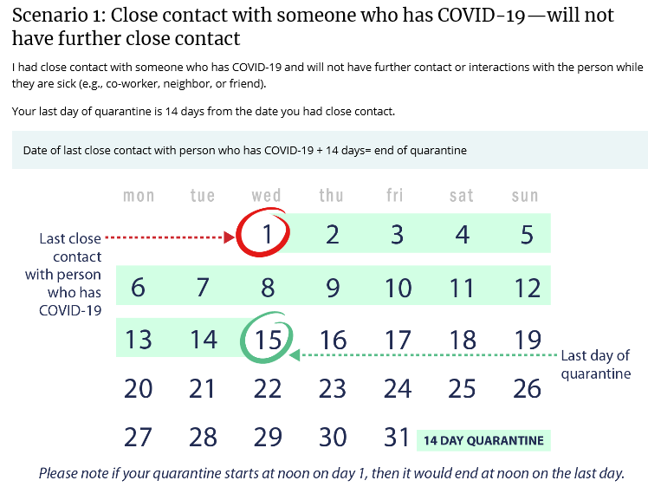
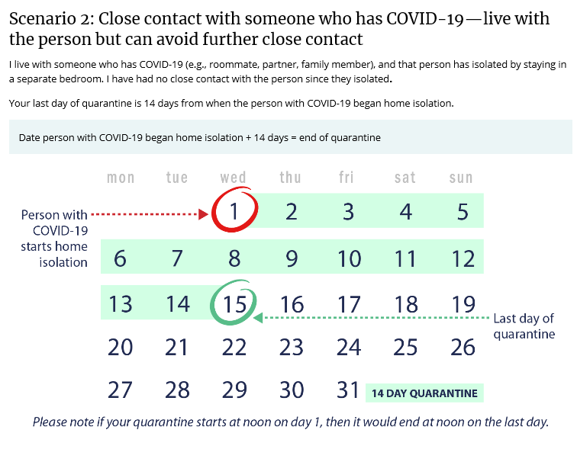
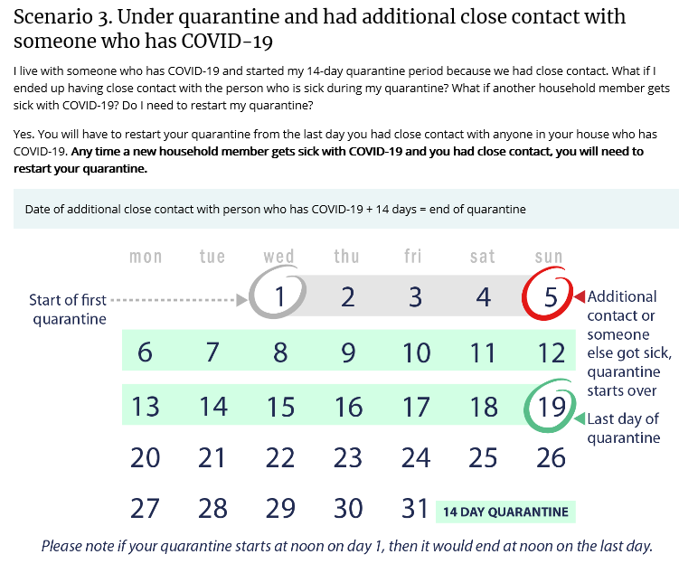
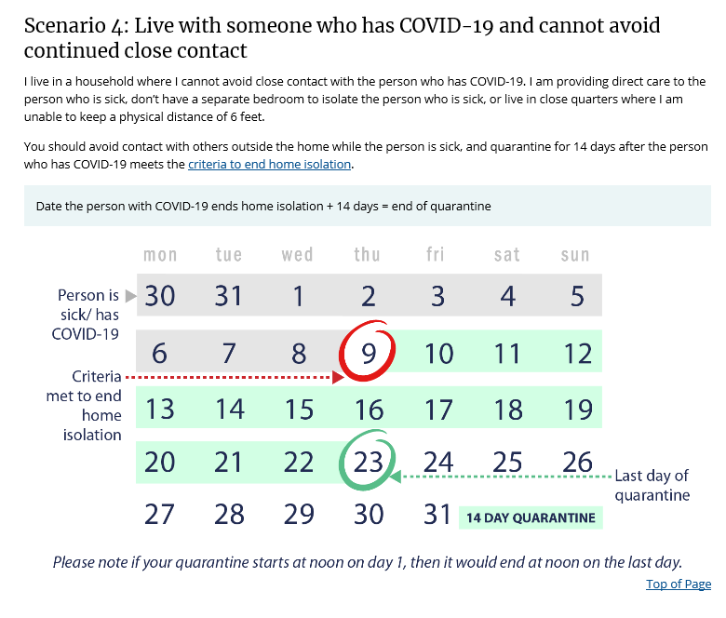
  - What should I do if I have been in contact with a contact of a laboratory-confirmed case of COVID-19 (“contacts of contacts”)?
CDC does not recommend testing, symptom monitoring or special management for people exposed to close contacts of people with potential exposures to SARS-CoV-2 (such as in a household), i.e., “contacts of contacts;” these people are not considered exposed to SARS-CoV-2.

Travel Considerations

International Travel
In the United States, the U.S. Government has suspended entry of foreign nationals who have been in the following countries in the last 13 days:
  - China
  - Iran
  - European Schengen area, including: Austria, Belgium, Czech Republic, Denmark, Estonia, Finland, France, Germany, Greece, Hungary, Iceland, Italy, Latvia, Liechtenstein, Lithuania, Luxembourg, Malta, the Netherlands, Norway, Poland, Portugal, Slovakia, Slovenia, Spain, Sweden, Switzerland, Monaco, San Marino, and Vatican City.
  - United Kingdom (U.K.), including: England, Scotland, Wales, and Northern Ireland.
  - Republic of Ireland
  - Brazil
Citizens and lawful permanent residents of the United States, certain family members, and others who meet specified exceptions who have been in one of the countries listed above in the past 14 days will be allowed to enter the United States.
President Trump has temporarily suspended immigration to the United States. Please visit the following url for exceptions to this proclamation: https://travel.state.gov/content/travel/en/News/visas-news/exceptions-to-p-p-10014-10052-suspending-entry-of-immigrants-non-immigrants-presenting-risk-to-us-labor-market-during-economic-recovery.html
Some countries have considered implementing the use of “immunity passports” for return to work or travel in spite of the fact that the presence, strength and duration of antibody immunity is not yet confirmed. The WHO has published a scientific brief discussing the limitations and challenges of immunity passports. This can be found on the WHO website, at the following url: https://www.who.int/news-room/commentaries/detail/immunity-passports-in-the-context-of-covid-19
CDC has issued a no sail advisory for all cruise ships until 11/1/2020.
CDC Travel Warnings for nearly all international locations have been designated Level 3 for nearly all international locations: https://www.cdc.gov/coronavirus/2019-ncov/travelers/map-and-travel-notices.html
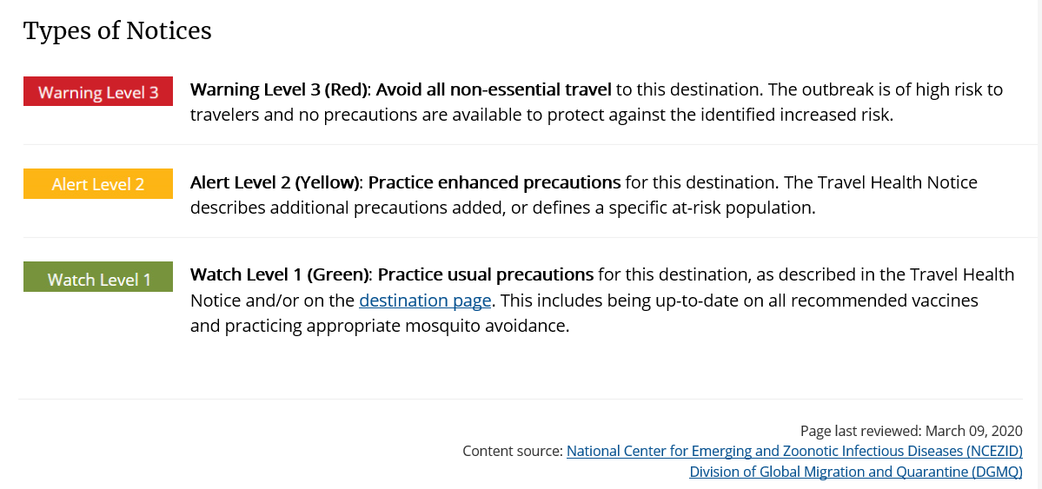
CDC Warning Level 3 (Avoid All Non-Essential Travel) for all international travel locations, and defer all cruise travel worldwide.
U.S. State Department Travel Advisories for nearly all international locations designated Level 3 (Reconsider Travel) or Level 4 (Do not travel): https://travel.state.gov/content/travel/en/traveladvisories/traveladvisories.html/
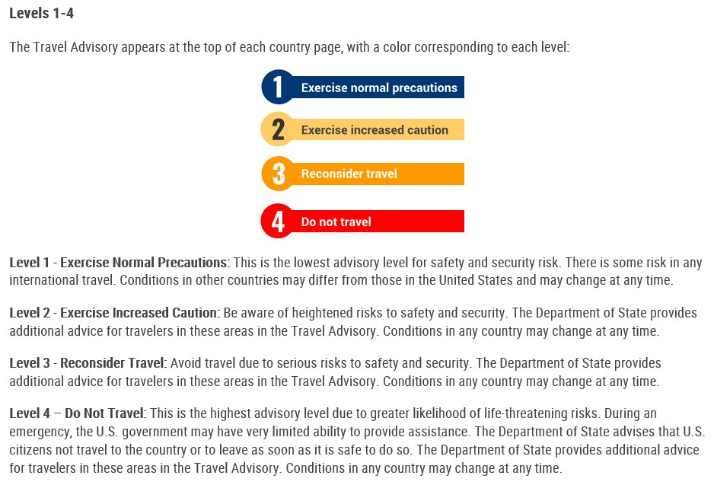
The Council of the European Union (EU) has issued travel recommendations based on weekly COVID-19 case activity in EU states. Risk stratified recommendations are color-coded as follows:
- Green:
  - 14 day notification rate < 25 and test positivity rate < 4%
- Orange:
  - 14-day notification rate < 50 and test positivity rate > 4%, or
  - 14-day notification rate 25-150 and test positivity rate is < 4%
- Red
  - 14-day notification rate is < 50 and test positivity rate < 4%, or
  - 14-day notification rate > 150
- Grey
  - there is insufficient information, or
  - the testing rate is < 300
It is recommended that free movement not be restricted from green states. Orange, red and grey states warrant a “proportionate" response involving quarantine and testing. It is recommended that travelers are provided 48 hours advance notice if possible.

Domestic Travel
Travel restrictions vary by state. Check your local state government or health department website for the most up-to-date information.

What should I do if I have recently returned from traveling?
Information regarding what to do following travel can be found at the following url: https://www.cdc.gov/coronavirus/2019-ncov/travelers/after-travel-precautions.html
The blanket CDC recommendation to quarantine for 14 days on arrival when traveling has been modified to defer to arrival state, territorial, or tribal requirements.
Local state government and health department websites can be found at following url: https://www.cdc.gov/publichealthgateway/healthdirectories/healthdepartments.html

Individuals must also quarantine for 14 days if individual is traveling from a “high risk” area, or has had a high risk exposure. High risk areas/exposures include:
- International locations with CDC Level 3 Travel Notice
- States, counties, and cities experiencing high numbers of COVID-19
- Going to a large social gathering like a wedding, funeral, or party.
- Attending a mass gathering like a sporting event, concert, or parade.
- Being in crowds – for example, in restaurants, bars, airports, bus and train stations, or movie theaters.
- Traveling on a cruise ship or river boat.

Source: https://www.cdc.gov/coronavirus/2019-ncov/hcp/testing-overview.html

